EXP 09: Steering Angle Variation in MIMO Beamforming
AIM :
To simulate the effect of varying steering angles in a MIMO beamforming system using MATLAB and analyze how beam direction changes with angle adjustment.
THEORY :
MIMO beamforming uses multiple antennas to transmit signals in a specific direction by adjusting phase shifts across antenna elements.
The direction of the beam is controlled by the steering angle (θ).
For a Uniform Linear Array (ULA), the array factor is:
$$AF(θ)=\sum_{n=0}^{N-1}{e^{jnkd(sin⁡θ-sin⁡θ_{0})}}$$
Where:
- $N$= number of antennas
- $d$= spacing between elements
- $k=\frac{2π}{λ}$(wave number)
- $θ_{0}$= steering angle
By changing $θ_{0}$, the beam direction shifts, demonstrating beam steering capability in MIMO systems.

PROCEDURE :
- Define parameters: number of antennas (N), wavelength, element spacing, and angle vector.
- Choose steering angles (e.g., 0°, 20°, 40°, 60°).
- For each steering angle, compute the array factor using MATLAB.
- Normalize the array factor for plotting.
- Plot AF vs. angle to observe beam steering.
- Compare how the main lobe shifts for different angles.

PROGRAM :
% Steering Angle Variation in MIMO Beamforming
clear; clc; close all;

N = 16; % Number of antennas
d = 0.5; % Spacing (lambda/2)
lambda = 1; % Wavelength
theta = -90:0.1:90; % Angle scan
th = deg2rad(theta);

% Different steering angles to compare
steer_angles = [-30 0 20 45];
colors = {'r','b','g','m'};

figure; hold on;

for s = 1:length(steer_angles)

th0 = deg2rad(steer_angles(s)); % Convert to radians

% Digital beamforming weights
w = exp(1j*2*pi*(d/lambda)*(0:N-1)'*sin(th0));
w = w / sum(abs(w)); % Normalize

% Compute Array Factor
AF = zeros(size(th));
for i = 1:length(th)
ph = exp(1j*2*pi*(d/lambda)*(0:N-1)*sin(th(i)));
AF(i) = abs(sum(w.'.*ph));
end

AF = AF / max(AF); % Normalize

plot(theta, AF, 'LineWidth', 2, 'Color', colors{s});
end

grid on;
xlabel('Angle (degrees)');
ylabel('Normalized Array Factor');
title('Steering Angle Variation in MIMO Beamforming');
legend('-30°','0°','20°','45°');
OUTPUT :
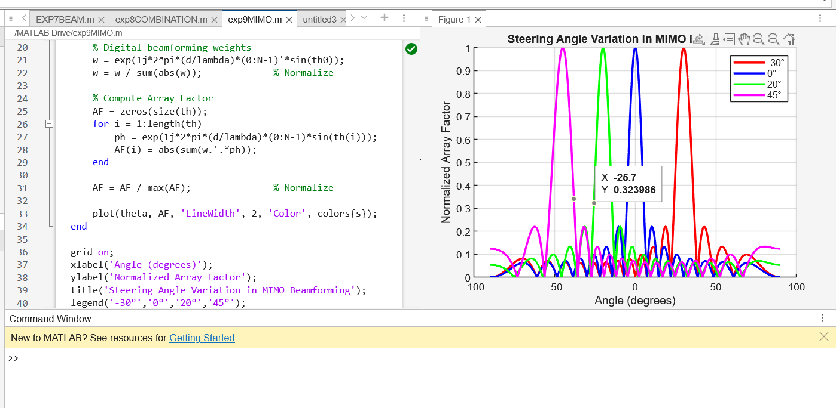

CONCLUSION :
The MATLAB simulation demonstrates that varying the steering angle effectively changes the direction of the radiated beam in a MIMO beamforming system.
This behavior matches theoretical expectations and illustrates how MIMO beamforming allows directional transmission for improved signal strength, interference reduction, and enhanced system performance.

